How to debug slow query

1. Find this SP. This going to be a SP or Function I guaranteed.
2. Run **SQL Profiler** to find that SP

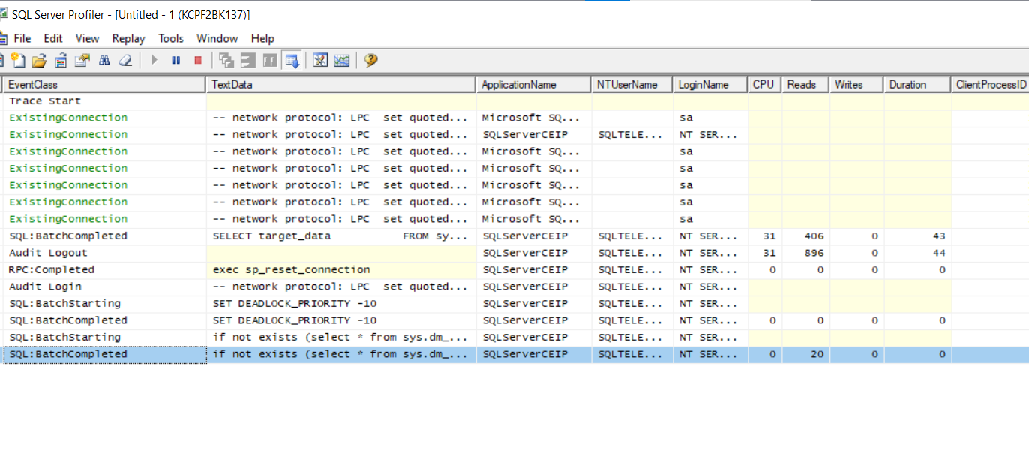  
3.) Take a look at that procedure make sure query statement is acceptable  
4.) Find the table in that SP that is getting to many records.

5./) Run **execution Plan** – This will find the query that taking forever. Replace it if you find some alternatives.

6.) Inspect table structure and entity

7.) Eliminate subquery .

8.) check for temp table. This should be deleted right away and immediately.

9) Count the record being pulled on that table.

RUN **ACTIVITY MONITOR**

**QUERY STORE** – this is very nice

ET STATISTICS TIME, IO ON this will give information on the sql statement being run

THERE A RE SO MANY TOOLS OUT THERE

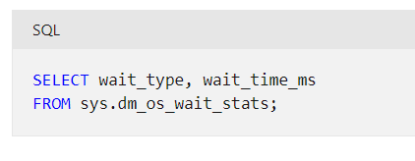

Always do a research on how to make database run fast. Base on my experience its always going to be a poor query statement. Data that are not needed in a query etc.